

College of Science and Technology

School of Science and Technology

# SOFT30121: Advanced Analysis and Design

# Systems Analysis Design and Implementation

*By*

N0683858: Hamid Mujtaba

T0084963: Haowei Goh

N0688119: Elliot Harding

N0756079: Steffan Walker

N0704050: Michael Abraham

N0772082: Hamed Alshebli

NTU Stores Management System

SOFT30121: Advanced Analysis and Design i

Systems Analysis Design and Implementation i

1. Introduction 3

1.1. Purpose 3

1.2. User Characteristics 4

1.3. Assumptions 5

1.4. Scope and Constraints 5

1.5. Glossary of terms 7

1.6. Overview 7

2. Functional Requirements 7

2.1. Usability requirements 11

2.2. Reliability requirements 11

2.3. Performance requirements 11

3. Non-Functional Requirements 10

3.1. Usability requirements 11

3.2. Reliability requirements 11

3.3. Performance requirements 11

4. Interfaces 14

5. Use Case Modelling 30

5.1. Use Cases 30

5.2. Misuse cases 30

6. Project Plan: 31

References 33

7. 33

# Introduction

## Purpose

The purpose of this Software Requirements Specification document is to propose a system which will help the NTU staff to manage the stores. In an interview with Lisa, it was made clear that they currently do not possess a system which allows them to monitor the quantity of the products being consumed or to allow the (consumer) staffs to efficiently take the products. Instead, they write down the details on a piece of paper, from which the data is manually stored in 2 separate systems by the management staff; QuickBooks, which is responsible for creating an invoice for each department, and Sage, to update the database. The 2 systems mentioned are difficult to use, in addition to being time consuming and lack a lot of features making it hard for the staff to manage the stores.

According to Lisa, staff at the stores also find it difficult to keep track of stockout as the current system(s) do not update the database in real-time; they are made aware of the stock quantity only after creating an invoice.

Lisa also said they use their own alpha codes to identify products, which are hand written. Ultimately, she wanted some way for the consumer staff to just scan the products instead of writing their details on a piece of paper.

The proposed system will overcome these issues by combining the functionality of Sage and QuickBooks along with providing additional functional features, along with an up to date, straightforward user interface.

After the interview, the team identified the main system requirements including to; manage sock, create an invoice for each department, create a log of products taken, add new products on a catalogue, register products received from shipments, provide directions to help users find items, notify the staff about important events, such as low stock, or shipment dates.

In addition to these, the system will deploy a very simple, easy to use UI with minimal input which will require no prior knowledge on using management systems. It will also provide staff with a ‘basket’ feature which will allow them to checkout many items at once. There will also be an option for returning items, in case staff accidently take more than required.

The catalogue containing all available products will have pictures with a brief description of the items to help consumer staff identify them easily. All the data will be backed up on an external (cloud-based) database to avoid data loss. The system will also have restriction on some functionality depending on the user role; it will allow the admin to update roles.

The proposed system will have a feature which will allow the admin to create custom alpha codes for the products when registering them into the catalogue.

When registering products, the system will not have the feature to allow the user to scan products directly, however, it will include the functionality to read barcodes with the help of external hardware which will make it easier for the consumer staff to take items and the management staff to manage, as the system will update the database automatically.

## User Characteristics

The proposed product management system will include three kinds of users. The system privileges/features available to each of these will vary, as will their experience and knowledge of product management. The three types of users will include:

**Consumer**

The consumers will be comprised of university researchers/lectures who require the products available at the store. These users will be limited to removing and returning products to the store. They will not require much experience with virtual systems due to their limited usage of the system and the intuitive user interface which will walk them through the product removal process. The consumers will only need to understand the basic fundamentals of computer usage and graphical user interfaces in order to utilise the system. Interface basics such as clicking a plus to increment the quantity of a product, back arrow to move to the previous page etc. will be all that is needed of this user.

**Staff**

The staff will be the employees working in the store that are in charge of managing stock, receiving shipments and assisting consumers. This type of user will have greater system privileges than the consumer as they will be responsible for the systems store management features. The proposed system is designed to automate a large amount of the manual work needed in the current system and as such the work load is lessened. However, the staff will still be required to input data into the system such as shipment codes so that the system can update the log and the stock database. This will require staff to have some experience with data input in addition to graphical user interfaces. Experience with systems such as MS Excel will transfer easily to the proposed system.

**Admin**

The admin will be the store employees that have greater control over how the store is managed and run. The admin users will be responsible for managing the catalogue of items available to the consumers in addition to viewing logs of removed products and received shipments. Because admins will have greater control over the store as a whole, they will require management and stock control experience in order to fully utilise the system. The level of technical expertise will be similar to that of the staff.

**Apprentice**

The apprentice at the store will have the same privileges as the staff members for an inability to process shipments.

## Assumptions

Throughout this document various assumptions have been made. To provide clarity and allow to according changes to be made easily if the assumptions are incorrect, they have been listed below.

* The operating system on the computers in which the software will run is windows.
* Stores items won’t move around, so the directions feature of the system will work.
* A disclaimer is assumed to be required to sign in order to use the system.
* Stores computers are assumed to be connected to an internet connection.
* NTU will have an external hardware device for scanning products.

## Scope and Constraints

The system is intended to be comprised of two main components. Firstly, the software, designed as an executable, in which all the functionality and user interactions of the system will be housed. And Secondly, cloud storage-based database which will store all the systems corresponding data.

Design of the executable will be done using C# with windows forms using the IDE Visual Studio. Using windows forms limits the amount of restrictions in terms of design due to its high flexibility in this area.

The database will utilize SQL (Structured Query Language) in order to store and retrieve its data. As for cloud storage, the hosting website ‘Gear Host’ will be used, thanks to its free trail size databases. In order to link the two components together, php hosted on the gear host server with the database will be called by functionality of the executable.

While multiple instances of the system will be able to run at once, the stores will have a limited number of computers in which the software can run. This constrains the number of users who can use the system simultaneously. This however is not so much of an issue since users can wait for their turn to use the system.

Given that the data for the system will be stored within the cloud, the disk size of the computer on which the system will run is also a minimal constraint. Generally, software applications of similar complexity take up much less than a single gigabyte of disk data.

The size of available cloud storage will be constrained by cost. An initial test database (with minimal capacity) can be setup for free, but afterwards payments may be required in order to expand its capacity, unless of course NTU servers can be utilized for storage.

Given that the storage format of the previous systems product and user data is unknown, transfer to the new system may prove difficult. As a last resort the inventory of the store may have to be entered in manually into the new system, a time-consuming process.

Since data for the system is stored online in the cloud, for the system to function correctly, an internet connection would be required. As well as this, the transfer rate of the internet connection would be an additional constraint for the system.

The application will be written using windows forms and the .Net framework and therefore it will be compiled in an .exe format. This means that the operating system in which the software can run will be constrained to windows only (Or Linux with Wine, a windows emulator).

Due to different priorities in terms of usability for different users of the system, the UI will be constrained in terms of its design. Design layouts will need to take this into account. On top of this certain UI elements and features will need to be hidden for lower priority users.

## Glossary of terms

|  |  |
| --- | --- |
| **Term** | **Meaning** |
| IDE | Integrated development environment (Editor for software designers) |
| Actor(s) | Member(s) who will use the software |
| Story points | Values assigned to features and tasks of the system. Representing the scale of work of the item the points are assigned to. The raw values assigned are unimportant. What matters are the relative values between different tasks. |

## 

## Overview

This rest of the document contains details about the proposed management system separated into various sections.

Functional/non-functional requirements which are then further split into 3 categories; the requirements the system must have, should have and could have, which were written after carefully considering user requirements and needs.

The interfaces section purpose is to represent how the user interface of the system will be laid out based on the functional & non-functional requirements outlined previously. The thought process and justifications for the systems designed will also be outlined here.

The following section has use and misuse cases for the management system consisting of the main functional actions the system will and will not perform. The section will also include a use case diagram using the UML notation for a visual representation of how the system and its actors will interact.

The last section is about the project planning, where the details on the agile methodology the team used is discussed and the process of how we plan to implement the system. This section also includes the strengths and weaknesses of each individual member in the group.

# Functional Requirements

## Usability requirements

**2.1.1: Store the inventory of the store’s stock**

The system must utilise a database to store information on the products being sold, their quantities and the alpha codes used in store to uniquely identify products. This database should update in real time when products are removed from or returned to the store. Keeping a digital count of stock is more accurate and robust than written logs.

**2.1.2: Display currently available stock**

The system must display, in a catalogue style, the stock currently available in store. The information should include the products name, the products alpha code, a picture of the product and the quantity available. Since the consumer can find whether the product they require is stocked immediately, there is less time wasted searching and asking staff members if the product is available.

**2.1.3: Use a virtual basket when buying products**

When consumers go to remove an item, it must be added to a virtual basket along with any other products they might want to remove. This basket can then be “Checked out” when the consumer leaves the store and the products removed be registered in the system. Before checking out, the consumer should be able to add and remove products they have in their basket. Virtual baskets are used by a majority of online retail sites which makes the system more relatable to consumers and is also a quick and clear indicator of what a consumer intends to take from the store.

**2.1.4: Allow products to be returned**

The system must allow products to be returned that have previously been removed from the store. When a product is returned it will be inspected by a staff member before the return is registered which in turn updates the stock, the log and the invoice. Consumers may find they no longer need the product that they removed from store or that it was inspected incorrectly by staff. For this reason, a feature to return any product that was removed from the store must be implemented.

**2.1.5: Allow catalogue of products to be changed**

The admin users must be allowed to add new products and remove old ones from the stores catalogue of available products. Since the needs of consumers inevitably changes as time goes on, the ability to add new products to sell and remove old ones will be implemented to keep the store adapting to their customer’s needs.

**2.1.6 Create invoices**

The system must create an invoice based on information of what products have been removed, the price of the products and the department which removed the product. The invoice should be created at the end of the month. By generating invoices automatically, there is less workload on staff and a decreased chance of invoices being completed erroneously.

**2.1.7: Allow users to login to the system**

The system must facilitate logging in for three types of users. These users include:

* **Admin:**

All the privileges available to staff in addition to control over the catalogue

* **Staff:**

With ability to receive shipments and inspect returned items/shipments

* **Consumer:**

Only allowed to remove and return products from the store

**2.1.8: Convert supplier units to consumable units**

The system should convert the unit a product is bought and received in, to the unit that the product is consumed in at the store.

E.g. 1 Box of pens should be converted into the number of individual pens a box contains as pens will be removed from store individually.

Performing this conversion through the system reduces erroneous input and time spent processing deliveries.

**2.1.9: Register received shipments**

The system should allow staff members to input shipment data, such as supplier codes and quantity, so that the store’s inventory updates with the stock contained in the shipment. Allowing the stock to automatically update with the contents of shipments reduces the workload of staff and allows shelves to be refilled quicker.

**2.1.10: Allow stock inspection**

Stock that has arrived from shipments or been returned by a consumer should be stored in an inspection database separate to general stock. When stock has been inspected by a staff member it is then moved to the general stock database. Since products can be damaged upon delivery to the store or by consumers trying to make a return, it is important to have some method of inspecting products before they are re-introduced to the stores stock.

**2.1.11: Display tags for important information**

The system should display, on the product page, any important information relating to the product in question. Products which are toxic, explosive, radioactive or pose any kind of health risk should have this information displayed clearly and readily visible at the top of the product page. While products that pose health risks are usually labelled accordingly, it makes sense to include this information on the product page before the consumer attempts to handle a potentially dangerous item.

**2.1.12: Track items that expire**

Products that can only remain on store shelves for so long should be tracked through the system so that when expiry dates are close, the staff members are notified. Implementing this feature is important for product rotation whereby products with soonest expiry dates are placed closer to the front of a shelf and vice-versa.

**2.1.13: Provide directions to products**

The system could display a map of the store with a marker indicating the location of the desired product within the store. This feature will allow store management to adjust product placement within the store and still provide a means for consumers to find their desired product.

**2.1.14: Remind staff about deliveries**

The system could remind staff members with notifications about upcoming shipments/deliveries. The notifications would include the delivery’s time, products being delivered and any additional information such as whether special handling equipment is needed. Notifying staff of upcoming deliveries allows time to prepare for substances like gases that could require special handling procedures.

**2.1.15: Scan barcodes of products**

The system could allow users to scan barcodes of products to remove the need for manual input of data into the system. Barcodes would be scanned when consumers add products to the basket and when staff need to register received shipments as part of the store’s stock. Scanning barcodes would reduce the amount of data input work done by both staff and consumers and reduce accidental adding of products to the basket.

## Reliability requirements

**2.2.1: Reliable database language**

The system will use SQL for the databases it uses. SQL is an industry standard language designed for building reliable and robust databases which makes it a solid choice for the system. Usage of a good language will help make a database that is expandable and resistant to incorrect data input.

**2.2.2: Log the removal and return of products**

The system must keep a log of what products have been removed/returned by storing the products name, product alpha code, date and time of occurrence, the individual involved and their department name. Keeping a log of the removed products will provide something to calculate invoices from.

## 2.2.3: Backup data externally

## The system should backup any data it is storing locally, into an external storage location to prevent data loss. The data should be backed up to a cloud-based drive like OneDrive to ensure there is an existing backup in the event of data corruption or accidental deletion.

**2.2.4: Provide low stock warnings**

The system should notify staff members when the stock of a particular product is low so that more can be ordered in time. By promptly informing the staff of low stock, there is a lessened chance that the product a consumer requires will not be available which improves the stores reliability.

**2.2.5: Log received shipments**

When shipments are received and registered through the system, they should be logged in a database. The log should include the shipment’s Order Head with details about the shipment itself and the Order Line with details on the products and quantities included in the shipment. Logging the shipments received will give management a clear view of what products are being re-ordered frequently which is very useful information.

**2.2.6: Offline Buffer**

The system could include a buffer by means of storing a local copy of the product catalogue so that products could still be taken out if the system was not connected to the internet. When the system regains an internet connection it would then update the stock level and product removal log. This would prove useful as consumers would still require products from the store if the universities internet was disrupted.

## Performance requirements

**2.3.1: Memory efficient language**

The system must be written in a memory efficient programming. This will improve the systems performance and reduce the users waiting time for operations to happen.

**2.3.2: Real time stock update**

The systems must update the stock database as soon as a product is checked out of the store. Updating in real time provides the staff with information that is current and provides a more accurate representation of the stores current stock level.

**2.3.3: Responsive UI**

The graphical user interface should be responsive and receptive to the action’s users make. Interactions such as clicking the increment/decrement quantity buttons should quickly update the number of products in the basket. By making the interface respond swiftly, there is a lessened chance that users will make an erroneous click in anticipation of the interface updating.

**2.3.4: Multi-threading**

The system could make use of multi-threading to process multiple actions concurrently. Considering there will be multiple users making use of the system, a multi-threaded program would be able to handle user request quicker and more efficiently.

# Non-Functional Requirements

## Usability requirements

**3.1.1. Performance**

The system should have a simple interface design which provides customer/staff/admin’s an easy method of discovering what they want to do. Moreover, the simple design will make them comfortable and confident when using the system.

**3.1.2. Prioritization**

Staff and customers using the system should be provided different options within the system, tailored to their jobs/needs.

**3.1.3. Accessibility**

The systems features should be easily assessable using generic computer components such as a keyboard and mouse  
(Apart from scanned items which will be done with an external hardware device).

**3.1.4. Error Tolerance**

It is inevitable that users will make mistakes when using the system. Therefore, the system should be designed with a friendly model which is easy to remove errors and have methods in place which require double confirmation when performing an important action.

**3.1.5. User Engagement**

The system should interact with the user in an engaging manner, resulting in users being less likely to run into issues with the system.

**3.1.6. Personalization**

The system could have personalized elements to grow a more familiar reputation with the user.

## Reliability requirements

**3.2.1. Data Retention**

The system should persistently store data and records, as the data will need to exist for as long as the items it represents does within the stores do.

**3.2.2. Stability**

The system should be highly stable to not affect its users and to remain reliable.

**3.2.3. Error Counter**

The system could measure its errors to alert instability to staff.

## Performance requirements

**3.3.1. Response Time**

User interface actions and database transactions should occur in a timely manner to keep users engaged and make using the system worthwhile.

**3.3.2. Error Occurrences**

Errors that occur due to the system should be kept to a bare minimum.

**3.3.3. Workload**

Workload for each action could be kept to just the necessary parts to complete the action, to keep system resource use to a bare minimum,

# Interfaces

**3.1 User interfaces**

Design

The user interface is to be designed in a simplistic manner in order reduce the learning curve of the system. Thanks to controls in the UI following a similar layout to similar existing systems, staff should have little difficulties transferring their knowledge of previously used systems.

Controls such as buttons will have black outlines to provide clarity in their purpose and location as well as allow colour blind users to distinguish them from other controls. Any of these controls which are used on multiple pages will be situated in the same location for each page to be consistent, reducing cognitive load for the user.

Most pages of the system will have a distinguishable help button. Clicking on this button will open a popup describing the purpose of the page and of any ambiguous elements it may contain.

Colour Palette

Surface & background colours

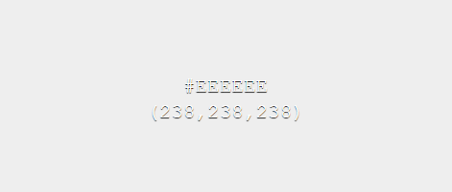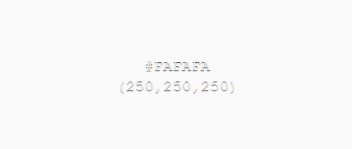

Error, message & action colours

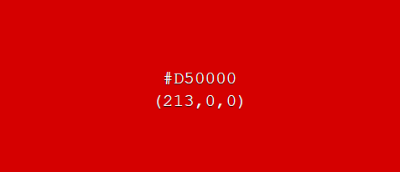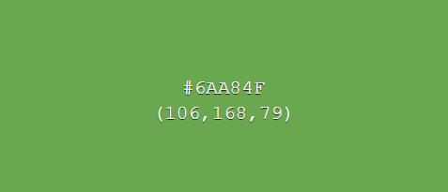

The chosen surface & background colours have been selected as weak toned colours as to not distract the user from more important UI elements. Two variants of the surface & background colours allow contrast between UI elements, such as distinguishing a background of a UI element and the system background, while keeping the same overall theme consistent.

In contrast, error, message and action colour tones have been chosen as bold colours, which draw users’ attention to important information.

GUI Mock-ups

Below are some example mark-up (not final) designs for how the system will look and act.

**Login page**

This page will be used by users to login to the system. An option for new users to sign up will also be available.

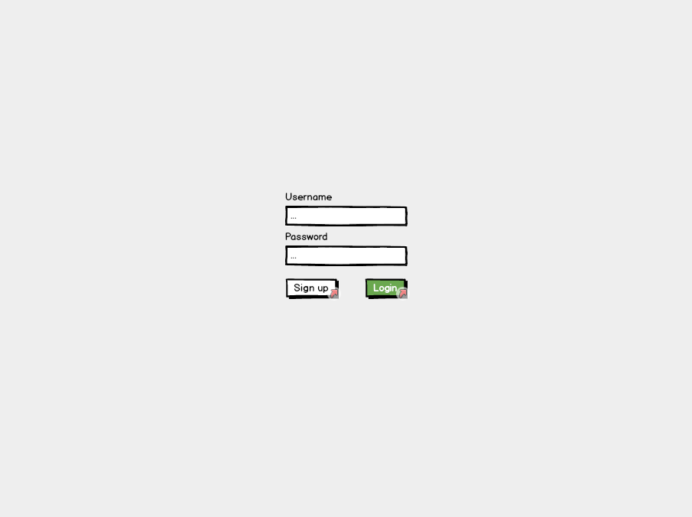

**Sign up page**

The sign-up page will be used by new users to sign up. Any disclaimer texts for users signing up will be displayed here. Users will be required to enter their N number so their account information can be linked with their NTU account.

Incentive for the creation of this page was in case a disclaimer was needed to be signed/read before users were able to use the stores.

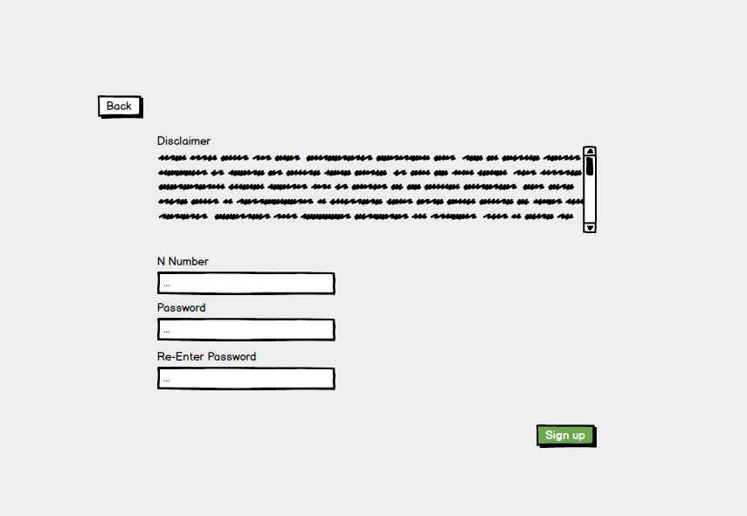

**Products page**

Once signed in users will be navigated to this page. From here products can be selected/searched for. A menu bar at the bottom of the page consistent across many screens will be available for navigating around the system.

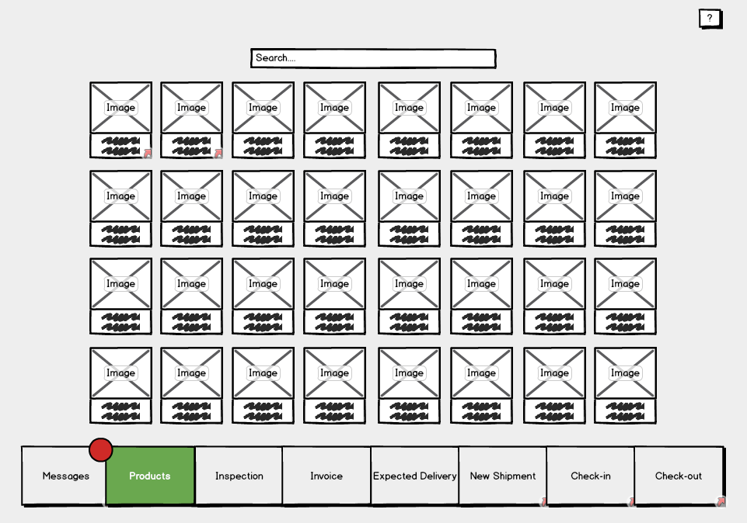

Users, as opposed to staff and admins, have less options and therefore their menu bar will be more simplistic.

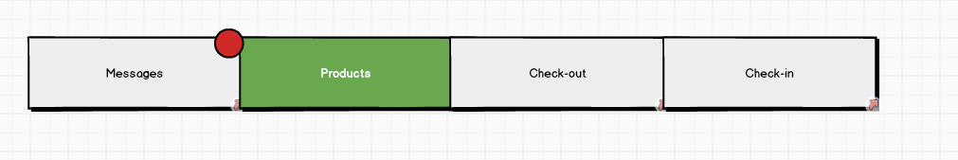

**Single product page**

This page will display the necessary information of a product. From here a user can add a product to their basket to checkout. A map of the location of the product within the store will also be available. If no items of the displayed product type are available users will be notified here as to when, if known, the next shipment of this product is expected.

This page will be navigable from various locations within the software in which products are shown.

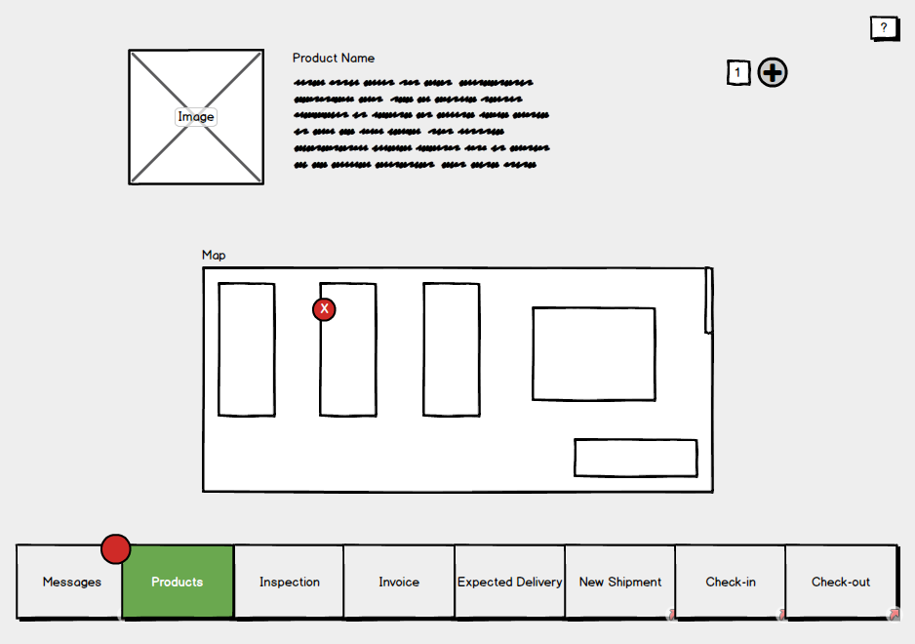

**Single product page (For staff & admins)**

Admins and staff will have access to more features on this page such as the ones shown below. Blue controls represent ones which only admins will be able to use.

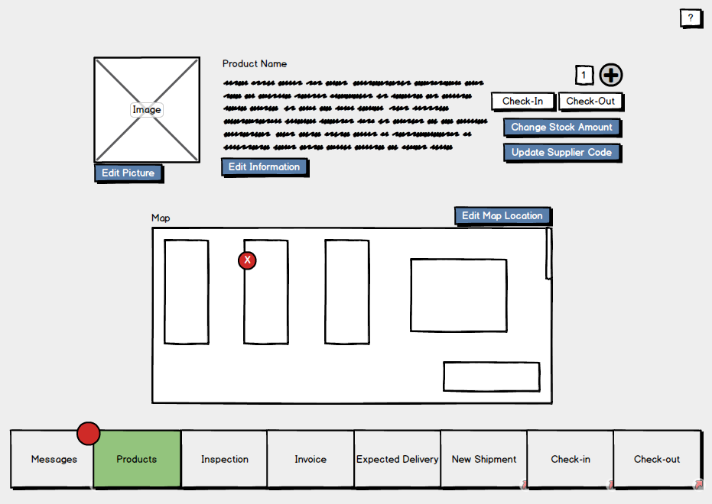

**Check out page**

This will be like a basket page seen on various shopping sites displaying a list of the products which the user wishes to checkout. Users will be able to remove items from this list, check the quality of the items and view their descriptions.

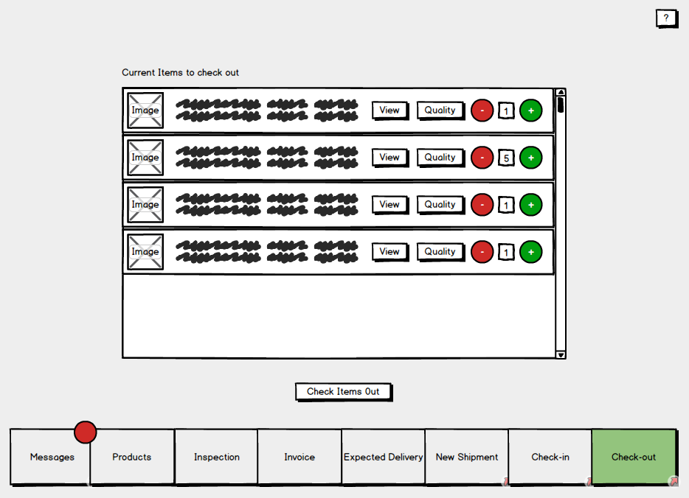

**Check-in page**

On this page staff will be able to search for a customer to see the items they have currently checked out. These items can be selected and checked back in. (This will send them either to the inspection database if it’s developed in time, or flag them as returned in stores)

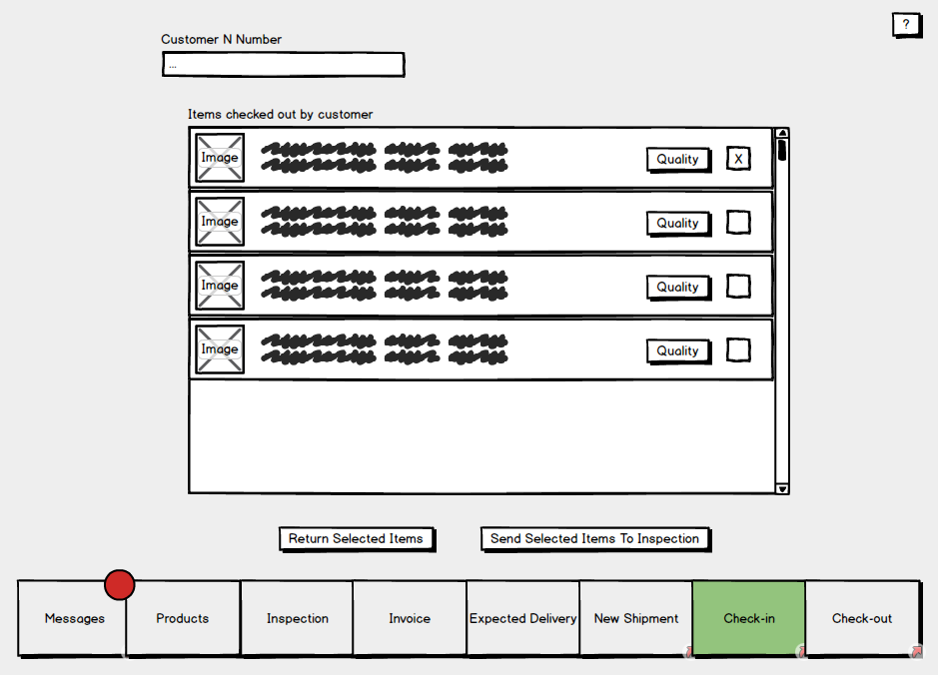

**Messages page**

The messages page will display messages for the logged in user. Categories of messages include; Overdue returns, products low on stock, expected shipments and expiring products.

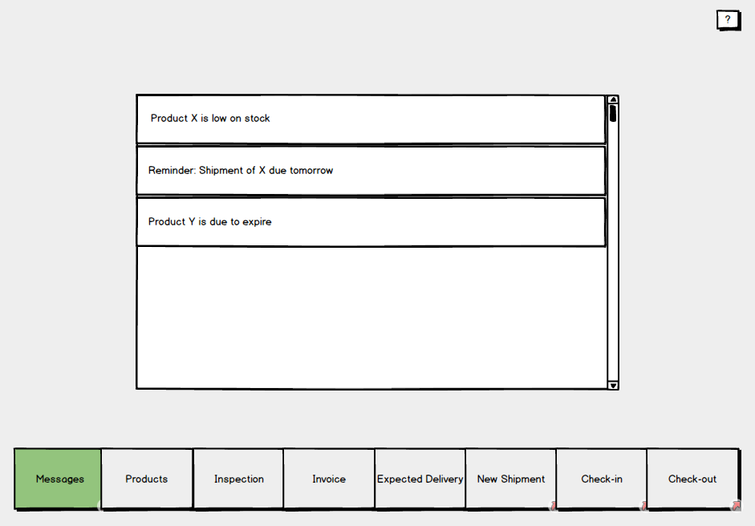

**New shipment pages**

This page, used by staff, is to enter information about an arrived shipment. Depending on weather the shipment is a repeat shipment the user will navigate to either the “Add brand new product” page or “Update stock shipment” page.

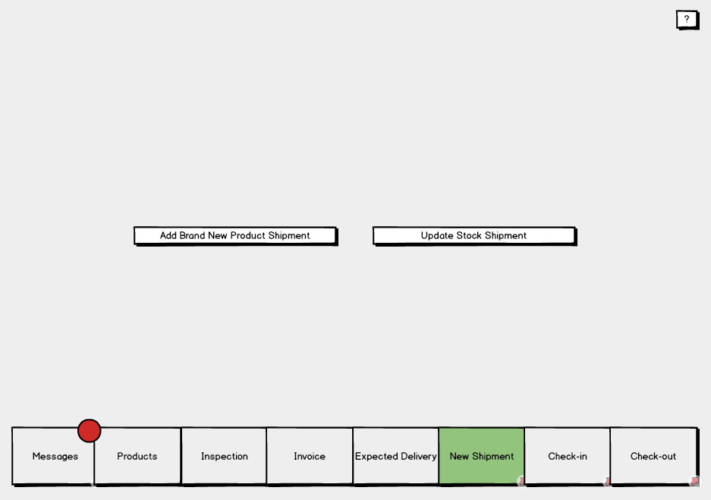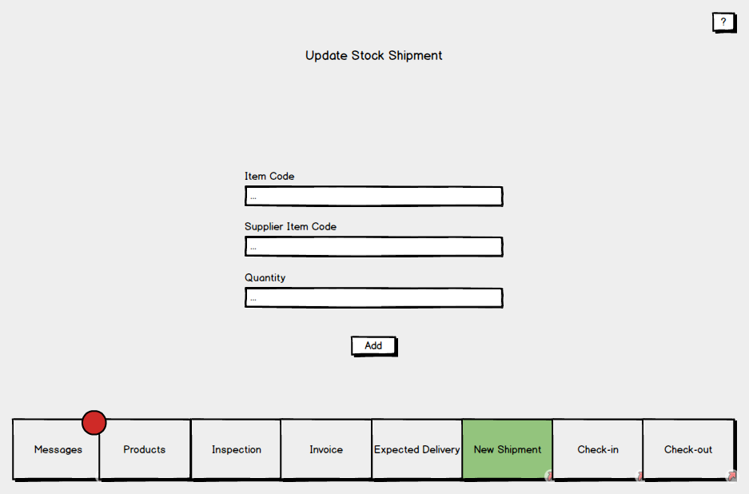

**Adding new shipments**

The process of adding new shipments is to be split up into two separate pages. First where shipment information is entered, and second where the items of the shipment are entered. These items will then be saved to stores.

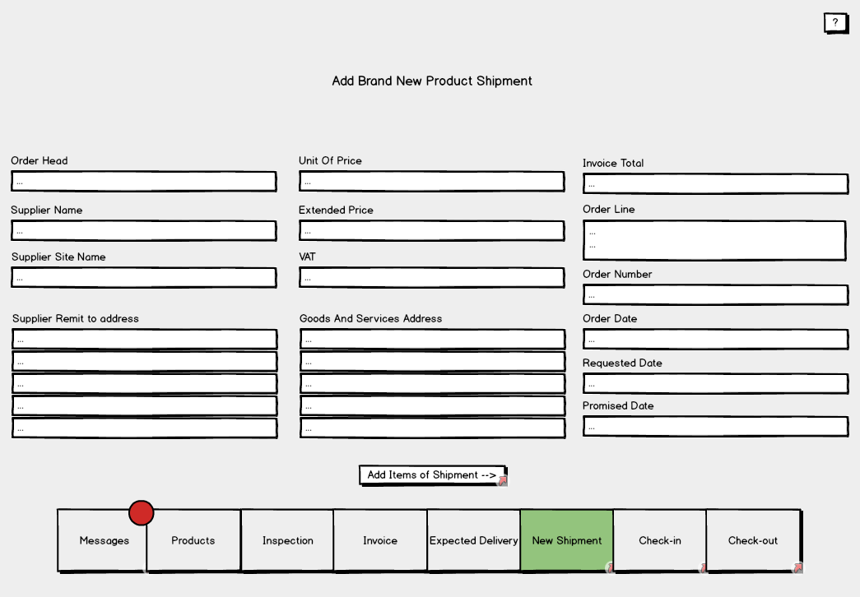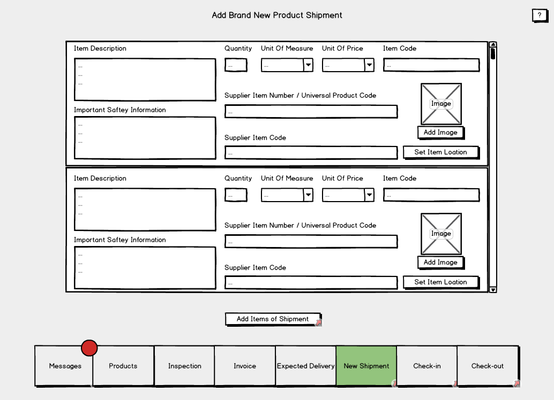

**Invoices page**

Two options are available on this page; A staff member can either add an invoice manually to be sent to a department, or, the invoice information can be filled in automatically from the systems invoice log.

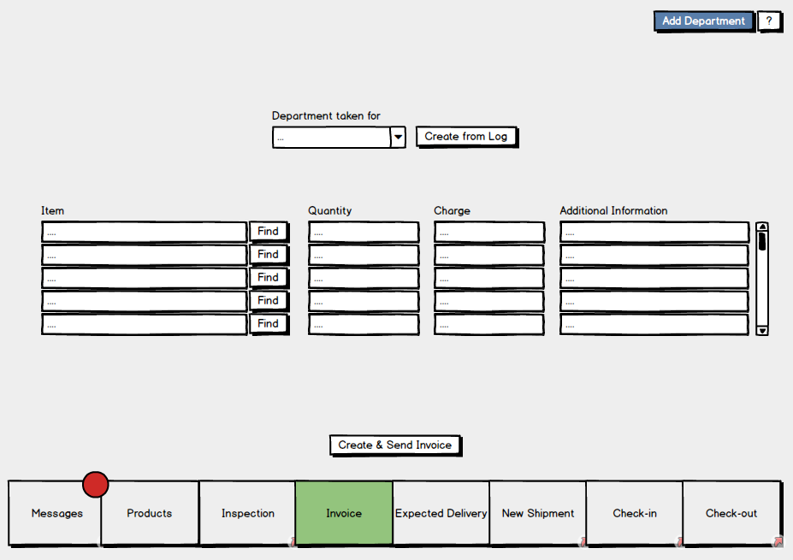

**Inspection page**

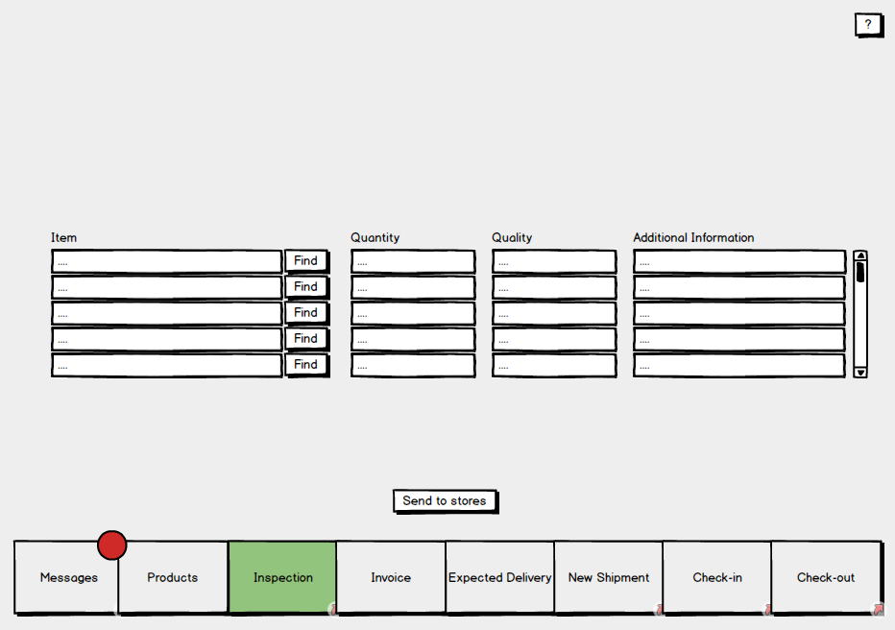

**3.2 Hardware interfaces**

Thanks to the system being software based there are only two hardware interfaces to be considered. Firstly, the systems interface with the barcode scanner, and secondly the interface between the system and computer on which it will run. Both interfaces will be used by staff, admins and customers.

**3.3 Software interfaces**

The diagram below illustrates the systems software interfaces.

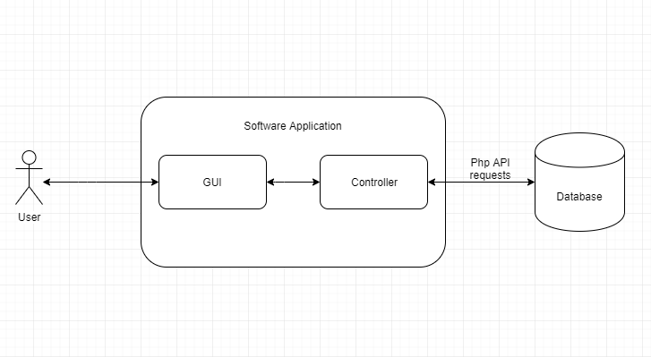

To transfer data between the database and the system the controller will make use of a database interface class. This will include the retrieval and uploading of; products, user data, transactions and invoices. In order to achieve its functionality, the interface will make use of the internet via PHP API requests.

The systems backend will be linked via an interface to the GUI. This link will provide the user with a method of accessing the systems features.

# Use Case Modelling

## Use Cases

Below are the use cases of the system which organise the systems requirements into manageable chunks for development purposes.

|  |  |  |  |  |
| --- | --- | --- | --- | --- |
| **Use Case Name:** Log in | | | **ID Number: 1** | |
| **Short Description:** This system allows user to log in using their credentials else if no credentials have been registered, they are able to create a new account. | | | | |
| **Trigger:** System activated once the program starts up or the previous user signs out. | | | | |
| **Type:** Internal | | | | |
| **Major inputs:** | | **Major outputs:** | | |
| **Description**  Username  Password  User Details | **Source**  User  User  User | **Description**  New User Account | | **Source**  Database |
| **Major Steps Performed:**   1. User is prompted to enter their username and password to gain access to the system. 2. Once the user enters the correct details into the system, they are then able to enter the default page for logged in users. 3. If no prior details have been registered with the system, then the user is able to move to a sign-up page in which they enter their ‘N number’ and create a password to gain authorisation. | | | **Actors & Roles:**  Consumer  Staff  Admin  All these users can create a new account however, different users will have different levels of authorisation.  All 3 actors defined as user in source | |

|  |  |  |  |  |
| --- | --- | --- | --- | --- |
| **Use Case Name:** Order Basket/Product Search System | | | **ID Number: 2** | |
| **Short Description:** This system allows the user to search for a product, so they can request the amount of the product they wish to take out. | | | | |
| **Trigger:** Entering product search system on the navigation bar. | | | | |
| **Type:** Internal | | | | |
| **Major inputs:** | | **Major outputs:** | | |
| **Description**  Product ID  Product Name  Quantity Taken | **Source**  Product  Product  Product | **Description**  Order Basket | | **Source**  Product |
| **Major Steps Performed:**   1. User can search for the product using the product ID, comprised of the alpha code and the products barcode. 2. The user must enter the amount they wish to take from the stock based on the products quantity units (i.e. ‘n’ packets of item). The product ID and corresponding quantity is added to order basket. 3. The user may wish to add another product to the basket or complete order basket and move onto the check-out system; if they require more products then steps 1 & 2 & 3 shall be repeated, else the order basket is ready to be processed. | | | **Actors & Roles:**  Consumer  Staff  Admin  All 3 actors can view products and add them into their order basket for checkout. | |

|  |  |  |  |  |
| --- | --- | --- | --- | --- |
| **Use Case Name:** Check-out System | | | **ID Number: 3** | |
| **Short Description:** This system allows the user to view the current items they have in their order basket and when confirmed, amends the stocks database with items they wish that have been removed. | | | | |
| **Trigger:** Pressing check-out tab on the navigation bar. | | | | |
| **Type:** Internal | | | | |
| **Major inputs:** | | **Major outputs:** | | |
| **Description**  Consumer N Number  Order Basket | **Source**  Consumer  Product | **Description**  Product quantity in stock | | **Source**  Stock Portfolio |
| **Major Steps Performed:**   1. Once items have been added to the order basket, on the check-out page, the basket becomes visible to the user as a list. 2. The user can view a short description of the products in their basket along with their images and the amount they wish to take out. 3. The user has a final chance to confirm the correct quantity of the product they wish to take before confirming the order; they can do this by either adding more or subtracting less to the quantity widget of the product in the order basket. 4. Finally, once the order has correctly been expressed to the system and the quantity taken is within the boundaries of the items stock amount, they can press the checkout button on the page and the quantity of products being removed will be amended in the stock control system. | | | **Actors & Roles:**  Consumer  Staff  Admin  All 3 actors can view products in order basket and confirm the order for checkout. | |

|  |  |  |  |  |
| --- | --- | --- | --- | --- |
| **Use Case Name:** Check-in System | | | **ID Number: 4** | |
| **Short Description:** This system allows the user to bring back any items they have previously checked out and amends the stocks database with records of its return. | | | | |
| **Trigger:** Pressing check-in tab on the navigation bar. | | | | |
| **Type:** Internal | | | | |
| **Major inputs:** | | **Major outputs:** | | |
| **Description**  Consumer N Number  Order Basket | **Source**  Consumer  Product | **Description**  Product quantity in stock | | **Source**  Stock Portfolio |
| **Major Steps Performed:**   1. User can search for staff members from the search bar, using their ‘N’ numbers in order to view the items they currently have checked out. 2. Once a valid staff number with current product loan history has been searched, a list of these items will become visible to users; stating the product, its associated image, a short description and the quantity that is currently out on loan. 3. The user is then able to select the tab or multiple tabs of the products they wish to return. 4. Once these selections of products are highlighted the user can then press the check-in button and the corresponding quantities of the products will be sent to the stock control system to be amended. | | | **Actors & Roles:**  Staff  Admin  Both actors have the capability to complete the check in process but will require the N number of the consumer. | |

|  |  |  |  |  |
| --- | --- | --- | --- | --- |
| **Use Case Name:** Process Shipments | | | **ID Number: 5** | |
| **Short Description:** This system allows the user to add and update product information when new shipments arrive to the warehouse | | | | |
| **Trigger:** Pressing the ‘New Shipment’ tab on the navigation bar. | | | | |
| **Type:** Internal | | | | |
| **Major inputs:** | | **Major outputs:** | | |
| **Description**  Product Information  Product Quantity | **Source**  Product  Product | **Description**  New product | | **Source** |
| **Major Steps Performed:**   1. When user enters the system, they are prompted to choose whether they wish to add a new product or update stock shipments. 2. If user selects update product shipment then they will be taken to a page where they must enter the item code, supplier item code and quantity. Once confirmed, this is then ready for step 5. 3. If new shipment is selected, then the user must firstly enter the information about the shipment; order head, supplier name, supplier site name, supplier address, unit of price, invoice total, order number, order date, request date and promised date. 4. Once the shipment information associated to the products have been entered then user is required to enter and confirm the details for each product received; item description, quantity, unit of measure, price, item code, supplier item code and an image. 5. Finally, the corresponding details given for whichever selection (new or update product shipment) is sent to the stock control system to either update or create a new instance of the item. | | | **Actors & Roles:**  Staff  Admin  Both actors can add details of new shipments and new products into the system, although admin is the only actor eligible to order a new shipment | |

## Misuse cases

|  |  |  |  |  |
| --- | --- | --- | --- | --- |
| **Misuse Case Name:** Log in (Incorrect authorisation) | | | **ID Number: 1** | |
| **Short Description:** This misuse case looks at when the user attempts to log in using credentials that are incorrect or unregistered. | | | | |
| **Trigger:** Failed verification of user credentials | | | | |
| **Major inputs:** | | **Major outputs:** | | |
| **Description**  Username  Password  User Details | **Source**  User  User  User | **Description**  Error Message | | **Source** |
| **Major Steps Performed:**   1. User is prompted to enter their username and password to gain access to the system. 2. The user then continues to enter a username and password that is either not registered in the system or do not match. 3. An error message is thrown to the user; now visible shall display ‘Incorrect user credentials’ 4. User is once again prompted to enter a valid username and password or to register a new account. | | | **Actors:**  Consumer  Staff  Admin | |

|  |  |  |  |  |
| --- | --- | --- | --- | --- |
| **Misuse Case Name:** Check-out System (Wrong Data Input) | | | **ID Number: 2** | |
| **Short Description:** This looks at the check-out system when confirming an order whilst the quantity of the items being withdrawn exceed the stock levels recorded of the item. | | | | |
| **Trigger:** Order basket confirmed by pressing check-out button with invalid quantity amount. | | | | |
| **Major inputs:** | | **Major outputs:** | | |
| **Description**  Order Basket | **Source**  Product | **Description**  Error message (i.e. ‘not enough in stock’) | | **Source** |
| **Major Steps Performed:**   1. Once items have been added to the order basket, on the check-out page, the basket becomes visible to the user as a list. 2. The user can view a short description of the products in their basket along with their images and the amount they wish to take out. 3. If the user inputs the quantity, they wish to check-out and this figure is checked against the items in-stock amount. 4. If the quantity required is larger than that of the products in-stock amount, then an error message is thrown to the user stating how many is possible to be withdrawn. 5. The user is then required to re-enter the amount they wish to take out, staying within the boundaries of the products in-stock quantity. | | | **Actors:**  Consumer  Staff  Admin | |

Below are the use case diagrams representing the use cases above.

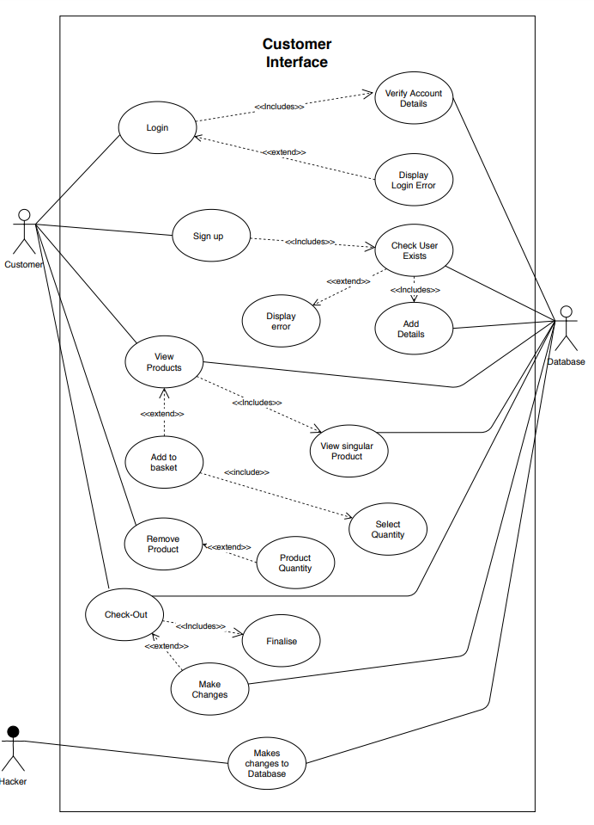

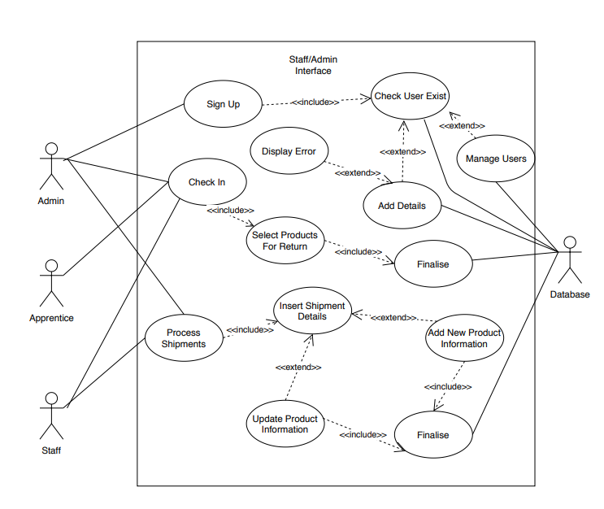

# Project Plan:

* 1. **Approach to development of the system**

The team would start by clearly writing job descriptions for each team member and making them available to every member of the team. Everyone must know their own and fellow members areas of responsibility.

To foster collaboration, the team would implement a specific type of organizational culture - clan culture - which would foster mentorship and team accountability. The teamwork combines individual commitment with group results, which makes it different from regular working groups, such as a function in a corporation. Team members would be assigned roles based on their transferable skills and skill potential, not for their personality (Principles of Management 499).

The team will work their ground rules by discussing expectations of collaboration, discipline, confidentiality matters, project approach, conflict resolution, to name a few. To set tasks and track performance, the team would equip the team members with a methodological framework and versatile tools. The framework would be scrum, one of the implementations of agile methodology. This framework supposes conducting everyday meetings mandatory for all team members where each member reads their tasks for the day, and the status of processed tasks is established. What is more important, everyone thinks of the ways they can help their colleagues succeed in fulfilling the daily tasks. In case the timeline gets challenged, a brainstorm for solutions is conducted. This way, the group would ensure a smooth work process for each member.

The issue of having all team members in one location is easily circumnavigated, since telecommuting is perfectly fine in the contemporary world. Communication would be conducted via emails, messengers, and video conferencing. Emails would be mainly for formal approvals and distributing minutes of meetings, messengers, such as WhatsApp, would serve as daily formal and informal communication channels; and video conferencing would be conducted in applications, such as Microsoft teams or Zoom.

Regarding the tools for building a system, GitHub proves to be an indispensable software development partner within the developers’ community. It encompasses code creation, integration, review, and overall team management. GitHub would also act as storage for other files such as documentation, requirements specifications etc.

Overall, team management is a challenging task. Leaders have to unite team members, supply them with measurable job descriptions, and equip with necessary tools for work. To remain productive, agile methodologies have to be welcomed. The crucial aspect is helping co-workers to reach mutual success.

Below are the assigned project roles based off-of members strengths in subjects which will be used to produce the software.

|  |  |  |
| --- | --- | --- |
| **Member** | **Project related strengths** | **Role** |
| Hamid | Visual studio, SQL, C# experience. | * Co-project leader * Software interfaces programmer |
| Elliot | Visual studio, SQL and PHP experience.  C# with windows forms experience.  Experience with development of similar applications. | * Co-project leader * Software interfaces programmer * UI programmer |
| Haowei | Visual studio, SQL, C# experience | * Database Programmer * Scrum leader |
| Steffan | Visual studio, SQL, C# experience. Proficiency in Photoshop, Illustrator (For UI design). | * UI Designer * UI programmer |
| Michael | Visual studio, SQL and PHP experience. | * Security programmer * Software Interfaces programmer |
| Hamed | Visual studio & SQL experience. | * Database Programmer * Security programmer |

* 1. **Backlog**

To track working time on each task, as well as their status, the team would introduce Azure Devops, a set of practices which would automate software development processes for the team. New assignments added to a backlog would then be moved to the stages, in progress, followed by approval, revision if necessary, and completion. These digital logs provide managers and employees with statistics regarding the productive time one works and allow predicting timeframes for upcoming projects.

Below is the initial backlog of the project.

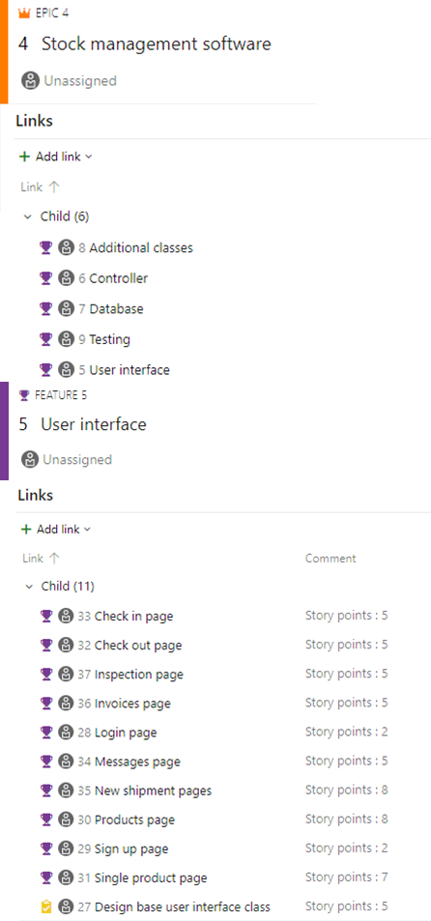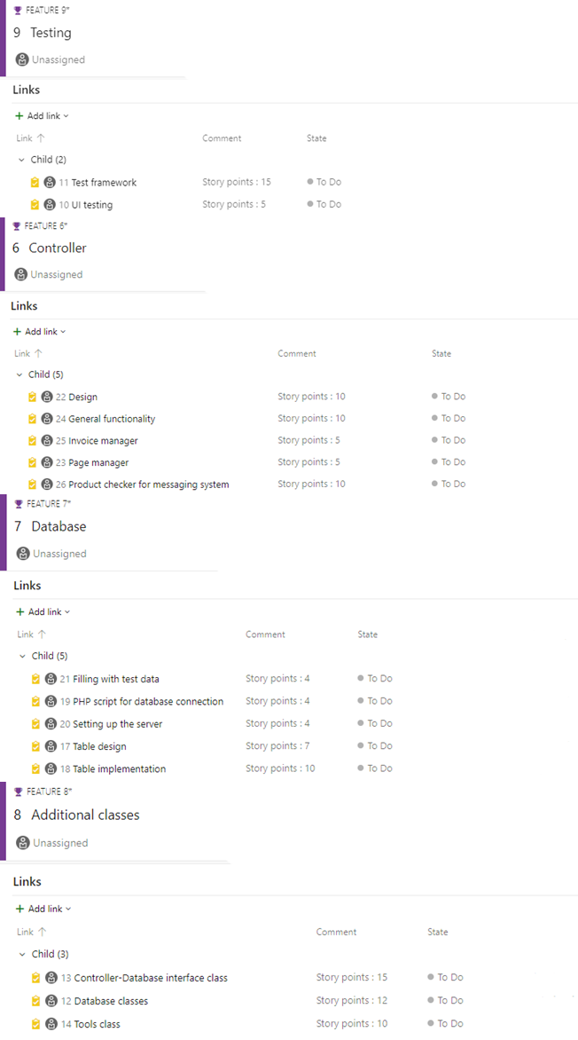

* 1. Gantt Chart

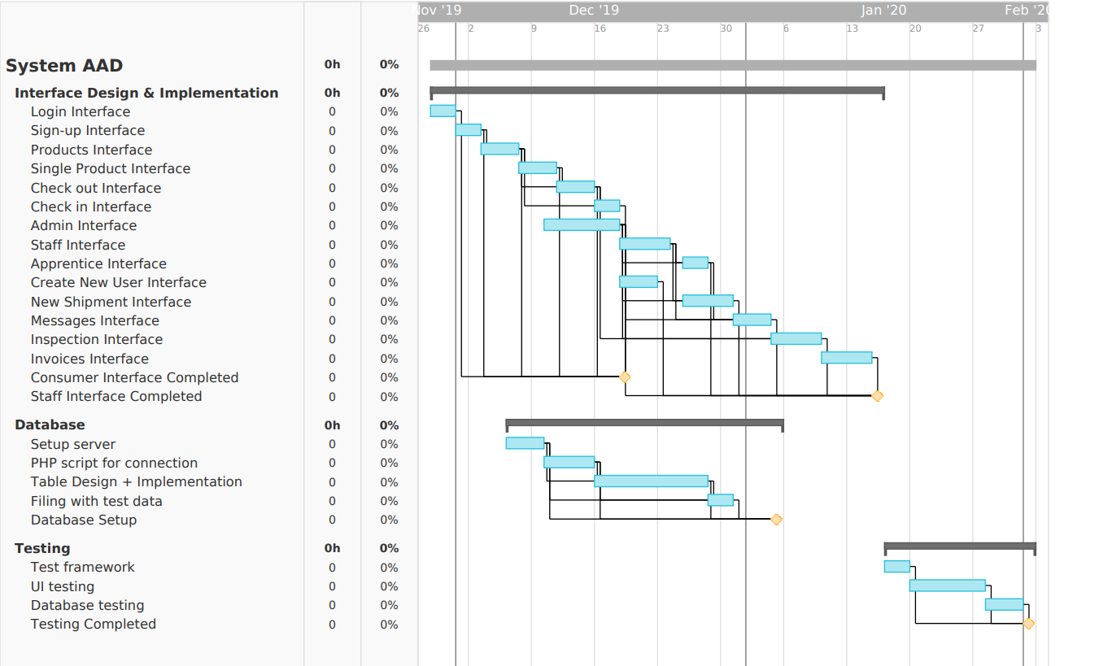

References

## 

*Principles of Management. Openstax. Roice University.*

(S Dhall & P Sundararaman, NA). C# AND .NET FRAMEWORK. https://www.cs.colorado.edu/~kena/classes/5448/f12/presentation-materials/dhall.pdf